**Nepali Samaj Programming Contest III, 2018**

**25th Jan and 26th Jan,2017**

Sponsorship Proposal

For

**Nepathya College**

‘’

Nepali Samaj Programming Contest 2018

**Mid of Jan-Feb**

**Reed Model School and College,** **Swoyambhu, Kathmandu**

The annual NSPC is the oldest programming contest in Nepal and have been our marquee event, which will attract over 500 peoples including participants, parents, future computer aspirants, companies, media, etc. This is going to be biggest and better because of

* More Participation will be seen
* More publicity will be done
* And has importance in carrier life of the participant
* And, by the presence of our honorable guests
* **Mr. Chiranjivi Nepal**

Governor of Nepal Rastya Bank,

* **Dr. Bilkis Jamal Ferdosi**

Associate Professor

Department of Computer Science and Engineering, University of Asia Pacific.

* **Dr. Manish Pokharel**

Head of Department, Computer Science and Engineering

According to the statistics all the participants are your potential employees and the audiences are your potential customers in Nepal. NSPC is an opportunity to showcase eSewa products and increase market share.

But, act soon – Sponsorships are now out for acceptance and we except a generous contribution from your side.

Attendees Profile

Event Propose

The NSPC started because programming quality in Nepal hasn’t been improved in a long time and a decline of Nepalese programmers has been seen in the global market. Neighboring countries like Bangladesh, India, and China are advancing at an exponential rate.

To overcome this problem Nepali Samaj made a plan which will take at least four years to establish respect in the global market and catch up with the present advancement already lead by our neighboring countries.

We decided the best way to solve the problem is to start with building the basic but he core quality of a student aspiring for a life in programming sector by coding.

We have come a long way, but we still need your support. Your generous contribution will help to shape the young minds of Nepal.

Advertisement Descriptions

1. Online Portals like facebook, youtube, twitter, online news.
2. National and Local News Papers, radio, TV.
3. T-shirt, bag, leaflet, booklet, posters, banner.
4. Banners will be distributed to all the participating colleges and will be displayed there reminding the students about the contest and sponsors.

Sponsorship Packages

|  |  |  |
| --- | --- | --- |
| Golden Sponsor | Silver Sponsor | Bronze Sponsor |
| Naming Rights to the event  (Extra NRS 2,00,000) |  |  |
| Live Plugs in opening & closing speech |  |  |
| Logo on accessories provided by NS to participants and coaches | Logo on accessories provided by NS to participants and coaches |  |
| Brand Promotion |  |  |
| Booth Space | Booth Space | Booth Space |
| Collaterals: flyers, banners, invitations | Collaterals: flyers, banners, invitations | Collaterals: flyers, banners, invitations |
| Electronic Collaterals: Web, email, videos | Electronic Collaterals: Web, email, videos | Electronic Collaterals: Web, email, videos |

|  |  |  |
| --- | --- | --- |
| Item | Contribution | Total Sponsors |
| Golden Sponsor | NRS. 4,00,000 |  |
| Silver Sponsor | NRS. 2,00,000 | 3 |
| Bronze Sponsor | NRS. 1,00,000 | 5 |

**Feature [Sponsor name] at Nepali Samaj Programming Contest Today!!**

**Expenditures**

|  |  |  |  |
| --- | --- | --- | --- |
| **Item** | **Pieces(NPR)** | **Rate(NPR)** | **Total (NPR)** |
| Prize Money + Shield + Token of Love +Medal +Crest |  |  | 1,00,000.00 + 40,000.00 |
| Internet + Technician + Bandwidth + backup PC + LAN configuration | 30PC | 800.00/day | (Provided By venue: 40PC + bandwidth)  48,000.00 |
| T-shirt (Coaches, participants, Volunteers) | 350 | 230.00 | 80,500.00 |
| Bag (Coaches, participants) | 300 | 650.00 | 1,95,000.00 |
| Buffet | 350 | 1,000.00 | 3,50,000.00 |
| Lunch Day 2 | 350 | 250.00 | 87,500.00 |
| Snacks Day 1(Mock Test) | 350 | 80.00 | 28,000.00 |
| Snacks Day 2 (Final Contest) | 350 | 70.00 | 24,500.00 |
| Notepad + Pen | 300 | 45 + 25 | 13,500.00+7,500.00 |
| Sound System |  |  | 60,000.00 |
| Decoration (Stage + others) |  |  | 1,00,000.00 |
| Problem Setters and Judges |  |  | 35,000.00 |
| Guest Badge + flowers | 20 | 250.00 | 5,000.00 |
| ID-Cads + ID without printed ribbon | 350 | 100 | 35,000.00 |
| Concert Band |  |  | 50,000.00 |
| Banner | 1500 sq feet | 35/ sq. foot | 52,500.00 |
| Accommodation for Distant participants | 20 Room  4 person per room | 2000.00 | 40,000.00 |
| Miscellaneous |  |  | 50,000.00 |
| Camps(Technical support+ problem Set+ Food+ Teachers + Hosting Contest + Judges) | 3 Days Camp  180 person |  | 25,000.00+35,000.00+  25,000.00+30,000.00 |
| Advertisement(Every participating college holds an event banner at their college) | In 30 colleges | 3,000.00 | 90,000.00 |
| **Total** |  |  | **16,07,000.00** |

**Sponsorship Term & Conditions**

The NSPC sponsorship contract (The “Contract”) states the terms and condition that governed the contractual agreement between (sponsor company) having its principal place of business at (“sponsor address”) (The “sponsor”), and Nepali Samaj (the “host”) who aggress to be bound by the agreement. WHEREAS, the host is conducting NSPC, programming contest on (date) (the “event”); and WHEREAS, the sponsor aggress to sponsor the event according to the terms and conditions herein. NOW, THEREFORE, in consideration of the mutual covenants and promises made by the parties hereto, the company & the sponsor (individually, each a “party” and collectively, the “parties”), covenant and agree as follows:-

**Contributions**

* The contribution for NSPC III is been decided to be fulfilled according to the sponsoring party involved & the following lists the individual contribution by [sponsor].

**Term/Termination**

The contract will terminate automatically upon completion of NSPC III.

**Changes/Cancellation**

Any changes made to this Contract must be in writing and signed by all the parties. If the Event is canceled, refunds will be made to the sponsors.

**Additional Terms**

1. A sample documentation of expenditure of funds will be presented to the sponsors and may increase or decrease depending upon the circumstance.

2. Full expenditure details will be presented to the sponsors before the end of the contract of sponsorship.

3. Golden Sponsors will have their logo on T-Shirts, but other companies logo may also be respected(printed) on the t-shirt if they tend to help us by contributing significant amount of fund.

**A brief history and motivation of Nepali Samaj**

1. To Polish and establish Nepalese computer aspirants in programming sector. (Problem solving, competitive Programming, Software debugging, etc.)
2. Establishing a sustainable education system for the future generation which will be self-sustained in sector of works, Nepali Samaj has been doing and will be doing in the future.
3. To assist Nepalese programmers in the national and international platforms and opportunities.(Jobs, entrepreneurships, social services, etc.)

**Initiatives**

1. Online NSPC I on 29th April, 2017
2. Onsite NSPC II on 1st July, 2017 engagement of 42 teams was achieved with several boot camps and training programs at several colleges alongside with a blood donation program.
3. ACM-ICPC Asia Regional Dhaka Site 2017 Participation on 10-11 Nov, 2017, first formal and fair Nepalese participation was ensured by Nepali Samaj.
4. National Level training and preliminary contests was organized to ensure the elite teams of Nepal are representing at the International venue at Dhaka.

**A Brief History and Motivation of Nepali Samaj**

With the aim of developing an IT platform that can be easily accessible and highly utilized in various sectors as per need. Various professionals from different field had come together to form this nonprofit, non-governmental organization Nepali Samaj on May 2017.

Nepali Samaj vision is firmly developing Nepal through IT resources.

We started on 29th April, 2017 Online Programming Contest, to till now 10 - 11th Nov, 2017 ACM-ICPC Dhaka Regional 2017.

During this 6 month of time period we were able to achieve another big goal which we think should be mentioned i.e. Successful participation of Nepali Coders in ACM ICPC Dhaka region contest held on November 10-11th Nov, 2017.

ACM ICPC which stands for Association for Computing Machinery International Collegiate Programming Contest is internationally recognized event held by Baylor University and is sponsored by IBM since 1977 AD. Past ICPC alumni populate much of the high tech information technology industries worldwide and has been seen as fertile ground for cherry picking by multinational companies. Among many regions that can conduct regional event Dhaka is one from where selected can go for World final in the Hosting country for the year.

This event is highly competitive and dynamic by nature which takes the participants to their limit in programming and algorithm implementations, and also tests their social skill as a team.

This event is of 5 hours and has 10 sets of questions which must be solved by coders’ chosen language except Python.

Nepali Samaj is driven to act for sustainable development of the country. History dictates, every nation winning at long term always had their plans and executions focused around the sustainable development. The key to this sustainable development is the IT workforce is with enhanced analytical skills. Benefits are beyond statements and examples.

And, we are aiming to establish ACM-ICPC Region itself, in Nepal by 2019AD.

Development of IT Field.

The prerequisite for our aim requires a vibrant IT platform and its community. It is highly encouraging time where we have seen works done in this field through different methods like developing education sectors, entrepreneurship, training, software developments etc. Though we felt this was not enough as we found difficulty to compare our IT professionals to international level. Also our colleagues are facing tremendous difficulty in competing with the international market of computing. As, everything in this near future will shift from just development to rigorous analysis of anything we can phrase. We have to build a workforce with a generic analytical skill.

As all the deeds are done with good intention, our retrospect found that it has been inadequate. So we have focused our initial goal in helping to produce highly competitive, dynamic and versatile pool of programmers.

For doing above issued statement we had come up with some steps and have been implementing them.

1. Establishment of online portals like website and Facebook pages for Nepali coders’ i.e Nepali samaj so flow of information and news can be done.
2. Introduction of various online programming contest focusing mainly in problem solving.
3. Capacity judgment and enhancement.
4. Categorizing of the coders based on the skills and need.
5. Tailored package for various categorized coders as per need
6. Conduction of online competition.
7. Interaction with international colleagues.

With our Facebook page we have been able to bring Nepalese coders together where they can have meeting, conversation, discussion as per need.

Till date we have successfully conducted more than 40 competition in various geographical regions of Nepal like Dharan, Pokhra, Biratnagar, Kathmandu, Jhapa, Butwal,Nepalgunj,Chitwan etc, and found the lacking that are the setback, of our IT workforce to fully enjoy their potential.

The major lacking that we have identified are

1. Knowledge of international quality.
2. Lack of programming skill.­­­
3. Interaction with professional personals in same domain.
4. Lack of competitive programming.

We have successfully conducted first onsite National competition on problem solving in July 1st 2017 in Butwal which was resoundingly successfully. It was a great contest as told by our participants and our partners.

During which we had given 2 days camp regarding the importance of problem solving for our coders.

Our event helped us to create needed buzz and flow of information in all the regions within the country.

With our high dedication and effort we were able to secure two slots for Nepalese coders at Dhaka regional event. ACM-ICPC started decades ago but still Nepal still don’t possess its own region. We are working on it too to ease out participation in the coming years.

After we got the slots in severe time limit at Dhaka site. We conducted a nationwide online contest. Two teams were selected based on the competition one from Butwal Multiple College, Butwal and another Institute of Engineering college, Pulchowk Campus, Kathmandu.

We took these two teams under our wings and initiated them into needed training course.

We employed the best problem solvers from Nepal and Bangladesh. National Level Champions and ACM-ICPC World Final Qualifiers.

It was first time that Nepal got officially invited to participate in such grand event. With the short timeframe of two months we were expecting high of maximum of 4 correct solutions from our teams. However they solved two problems which is a deserving score for the first time. Securing higher ranks than a lot of experienced Bangladeshi teams in the competition. We are happy with their efforts and foreseeing a tremendous improvement in the next year’s participation.

Above all they are now highly motivated since knowing that we can compete and even win which is our next year’s target.

These events and exposures are important for future careers development as seen in the employment part. Bangladeshi coders and Indian coders can be seen in huge numbers in major MNC companies like Microsoft, Google, Amazon etc. but our Nepalese coders, they can be counted in fingers or less. We aim to reverse this condition.

While targeting for such a high competitive environment we are sure our pool of coders will get quality and quantity of international standards.

We are looking forward to accept any helping hands in our movement. We expect our national and international companies doing business in Nepal show positive response in funding us as this will be needed for us if we tend to work effectively and smoothly.

As mentioned by some of our coders above we know we can reverse this trend and create highly dynamic, competitive and successful IT market in Nepal which can compete at international market.

Also with our social responsibilities in mind we had conducted our first blood donation program in Butwal on July 2017. Our members have also been highly active in several social issues like recent flooding in terai region. For which our member were able to collect money and clothes donated by Good Samaritans which was handed over to regional authorities.

Further, more we are planning to implement telemedicine in Nepal which will help to bring down the cost of medical diagnosis in Nepal. Doctors can diagnose and prescribe drugs online for all those condition which may need not travelling and bring cost done.

Medical Field is ours second goal. With all these in mind we have planned to conduct our third national level Programming Competition in Kathmandu, which we want to make appealing among the crowd of nepali programmers.

The Graph for NSPC III below dictates the participant’s engagement. Where Onsite data presented are actual participation in those events till date. Preliminary and Final are predicted.

**Nepali Samaj Gallery**

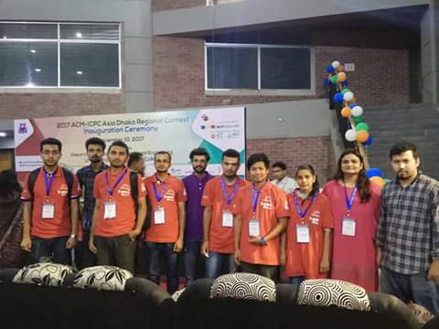

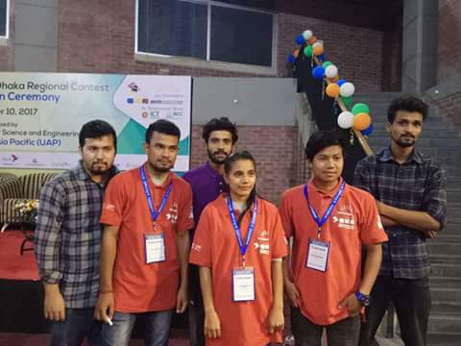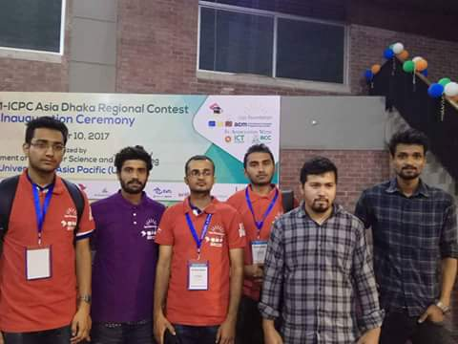

*ACM-ICPC Asia Regional Dhaka Site 2017*

*11th Nov, 2017*

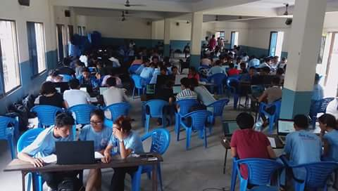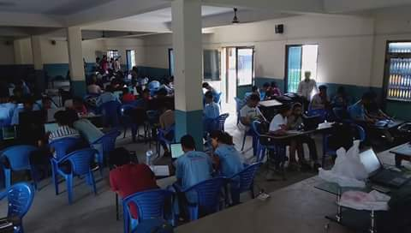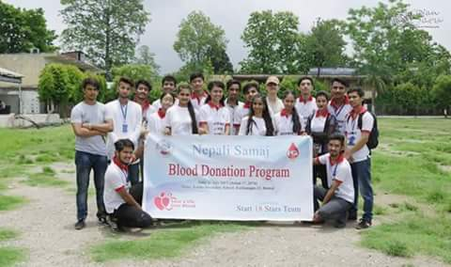

*Nepali Samaj Programming Contest II*

*July*